3 CH DMX CV Driver
Manual
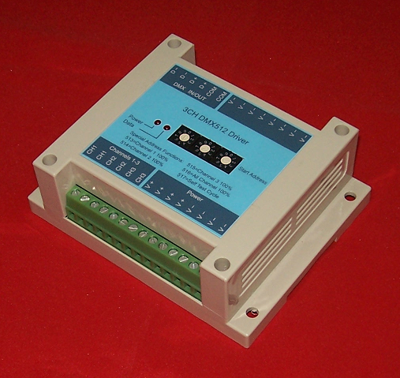
Features:
1. Compatible with the international standard DMX512 signal, 3 output channels, output current up to 10A per channel.
- Adopt a rotary switch to set DMX start address for the first time in our country, avoiding a series of drawbacks resulted from traditional binary dial-up, namely conversion difficulty, dialing fallibility, identifying problem, etc.
- Built-in many kinds of testing programs, implementing the offline operation easily without DMX main control.
- Each channel reaches up to 265 gray scale levels, supporting 16,770,000 different kinds of colors.
Technical Specifications:
Model: SPD-310
Input Voltage: DC 8-30V
Output Power: max 900W
Output Current: 10A*3 channels (sunk output)
Output Frequency: 100Hz
Digital signal input/output: DMX512
Size: 90(L)*115(W)*40(H) mm
Weight: 100g

SHANGHAI SEMPING ELECTRONICS CO.,LTD.
Add: Room 1706, NO. 868, Changping Road, Jing’an District, Shanghai
P.C: 200042
Tel: (86)21-5228 8520
Fax: (86)21-5228 8521
Web：www.dmx512net.com
Technical support ：support@dmx512net.com

