SPD-335 DMX CC Driver
Manual
REV 1.0
2008.11.3

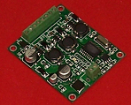
Summary
  - features:
1. Compatible with the international standard DMX512 signal, 3 output channels, 350mA constant current output per channel.
2. Wide range of DC power supply, DC9-30V, transfer efficiency reaches up to more than 90%, each channel can connect 1 to 8 high-power LED lights.
3. Each channel reaches up to 265 gray scale levels, 0-100% light-dimmer output, supporting 16,770,000 different kinds of colors.
4. Subminiature and industrial grade design, manufactured with 100% SMD, excellent robustness.
5. Support the DMX Address Writer to set start address.
1.2 Technical Specifications:
Model: SPD-335
Input Voltage: DC 9-30V
Output Power: 24 W
Output Current: 350mA±5%*3
Max number of LED lights: 3*8 1W LED
Digital signal input/output: DMX512
Size: 60(L)*50(W)*8(H) mm
  - Typical application
R, G, B full-color dimming application, high-power LED projecting light, high-power LED wall washing light, LED light of external wall.
Application information
2.1 Connection graph
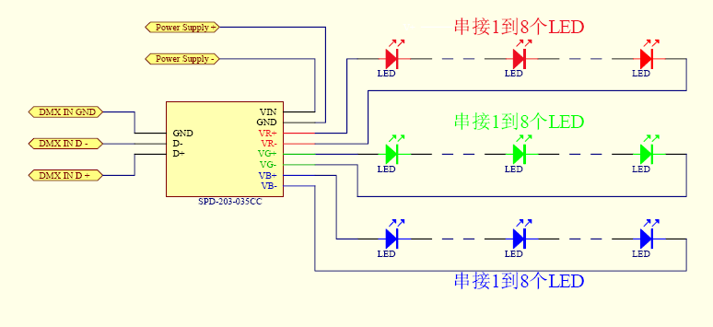

  - Interface function description
Interface name | Function description | Characteristic
VIN,GND | Power input | DC9-30V
D+,D-,GND | DMX512 signal input | 1/4 unit load allows of 128 drivers connecting to DMX512 bus. Each driver meets or exceeds standard DMX512/1990 and standard ISO/IEC 8482:1993(E).
VR+,VR-  VG+,VG-  VB+,VB- | 3 channels R, G, B output | 350mA Constant-current output per channel.
  - Setup of DMX 512 start address
Set start address of DMX512 through the Address Writer & Tester of our company, Please refer to SPC-512 manual before specific operation.
2.4 DMX512 control signal connection
DMX512 signal cable applies shielded twisted pair cable, DMX512 signal is divided into three categories: anode terminal, cathode terminal and GND. Take strict notice of polarity when DMX512 signal cable plug is welded. Connect signal anode, signal cathode and GND of DMX512 controller output with SPD-335’s corresponding interface. When the entire circuit is completed, it is supposed to link a DMX512 signal terminator.
2.5 Comparison between LED connection number and input voltage
LED number | Input voltage
1 | 9～12V
2 | 9～12V
3 | 12～24V
4 | 15～24V
5 | 18～24V
6 | 24～30V
7 | 28～30V
8 | 30V

2.6 System connection graph
SPD-335
3 CH CC Driver
LED board
SPD-335
3 CH CC Driver

SPD-335
3 CH CC Driver

DMX512 controller（SPC-2000）
（SC）
DV12-24V
Power supply
LED board
LED board

SHANGHAI SEMPING ELECTRONICS CO.,LTD.
Add: Room 1706, NO. 868, Changping Road, Jing’an District, Shanghai
P.C: 200042
Tel: (86)21-5228 8520
Fax: (86)21-5228 8521
Web：www.dmx512net.com
Technical support ：support@dmx512net.com

