3 CH DMX Driver
Manual
REV 1.0
2008.11.3

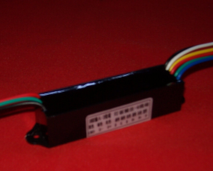
Summery
SPD-302 adopts advanced Microcomputer-based technology, compatible with standard DMX512/1990 to full extent. 1 to 3 channels output is available, each channel reaches up to 256 gray scale levels, 2A output at its maximum. It is widely applied to controlling and driving of city landscape lighting system, and the specific application is dimming of LED fixtures.
1.1 Features:
- Compatible with the international standard DMX512 signal, 3 output channels, output current up to 2A per channel.
- Built-in constant-voltage circuit, 8V to 28V input voltage range.
- Each channel reaches up to 265 gray scale levels, supporting 16,770,000 different kinds of colors.
- Waterproof and industrial grade design, excellent robustness.
- Support the DMX Address Writer to set start address.
1.2 Technical Specifications:
Model: SPD-302
Power supply input: DC 8-28V
Power output: max 168 W
Output Current: 2A*3 channels (sunk output)
Output Frequency: 100Hz
Digital signal input/output: DMX512
Size: 82(L)*23(W)*20(H) mm
  - Application scope
Architectural decoration: commercial space, airport, construction project, subway
Indoor decoration: hospital, restaurant, department store, square, café , PUB design lighting.
Advertisement shaded font , logo, signboard, advertisement lamp-case.
Application information
2.1 Wiring schematic diagram
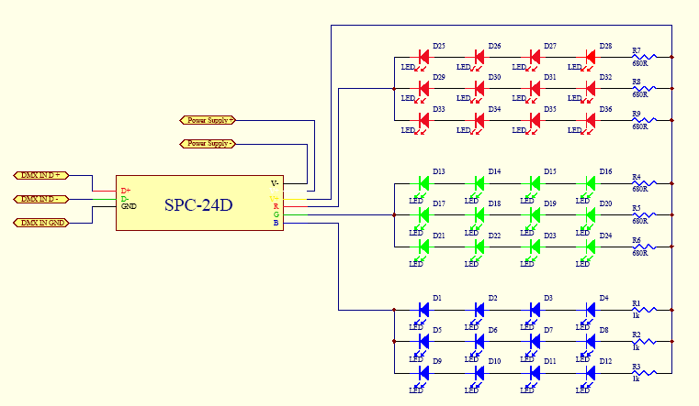
SPD-302
    - Common-anode full-color model sets can directly connect anode lines and line R, G, B to corresponding lines of output interface.
2.1.2 Monochromatic model set can connect anode line to line V+ of driven output interface, according to the color of this model set, cathode line is connected to a certain line of pin R, G, B in driven output interface.
2.1.3Monochromatic model sets with several colors are connected to an identical driven output interface, ensuring that all the anode lines connected to line V+ of driven output interface.
2.2. Description of interface function
Interface name | function | characteristic
V+,V- | Power supply input | DC8-28V
D+,D-,GND | DMX512 signal input | 1/4 unit load allows of 128 drivers connecting to DMX512 bus. Each driver meets or exceeds standard DMX512/1990 and standard ISO/IEC 8482:1993(E).
V+,R,G,B | 3channels driven output（source-drain open-circuit output） | Each channel output high level: below 28V，output current: below 2A，  PWM frequence:100HZ。

2.3 Setup of DMX 512 start address
Set start address of DMX512 through the Address Writer & Tester of our company, Please refer to SPC-512 manual before specific operation.
2.4 DMX512 control signal connect
DMX512 signal cable applies shielded twisted pair cable, DMX512 signal is divided into three categories: anode, cathode and GND. Take strict notice of polarity when DMX512 signal cable plug is welded. Connect signal anode, signal cathode and GND of DMX512 controller outputs with SPD-302’s corresponding interface. When the entire circuit is completed, it is supposed to link with a DMX512 signal terminator.
2.5 Power Calculation
The input/output voltage of this product has a wide rang（DC8-24V）, the rated output current is 2A per channel, therefore, the rated output power varies with different input voltage.
e.g.: the rated power under 12V voltage: 12V*2A*3=72W
the rated power under 24V voltage: 24V*2A*3=144W
2.6 System connection graph
SPD-302
3CH DMX Dimmer
LED fixture
SPD-302
3CH DMX Dimmer

SPD-302
3CH DMX Dimmer

DMX512 controller（SPC-2000）
（SC）
DC12-24V
Power supply

LED fixture
LEDfixture

SHANGHAI SEMPING ELECTRONICS CO.,LTD.
Add: Room 1706, NO. 868, Changping Road, Jing’an District, Shanghai
P.C: 200042
Tel: (86)21-5228 8520
Fax: (86)21-5228 8521
Web：www.dmx512net.com
Technical support ：support@dmx512net.com

