SPD-241 24CH DMX Dimmer
Manual
REV 1.0
2008.11.3

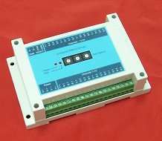

1. Summary
SPD-241 adopts advanced Microcomputer-based technology, compatible with standard DMX512/1990 to full extent. 1 to 24 channels output is available, each channel reaches up to 256 gray scale levels, 1A output at its maximum. It is widely applied to controlling and driving of city landscape lighting system, and the specific application is dimming of LED fixtures.
1.1 Features:
1. Compatible with the international standard DMX512 signal, 24 output channels, output current up to 1A per channel. Each channel can control 8 full-color RGB pixel points.
- Adopt a rotary switch to set DMX start address for the first time in our country, avoiding a series of drawbacks resulted from traditional binary dial-up, namely conversion difficulty, dialing fallibility, identifying problem, etc.
- Set the start address by either DMX Address Writer or rotary switch.
- Each channel reaches up to 265 gray scale levels, supporting 16,770,000 different kinds of colors.
1.2 Technical Specifications:
Model: SPD-241
Input Voltage: DC 8-28V
Output Power: max 670 W
Output Current t: 1A*24 channels (sunk output)
Output Frequency: 200Hz
Digital signal input/output: DMX512
Size: 90(L)*145(W)*45(H) mm
Weight: 100g
  - Application scope
Architectural decoration: commercial space, airport, construction project, subway
Indoor decoration: hospital, restaurant, department store, square, café, PUB design lighting.
Advertisement shaded font, logo, signboard, advertisement lamp-case.
2. Application information
2.1 Connection graph

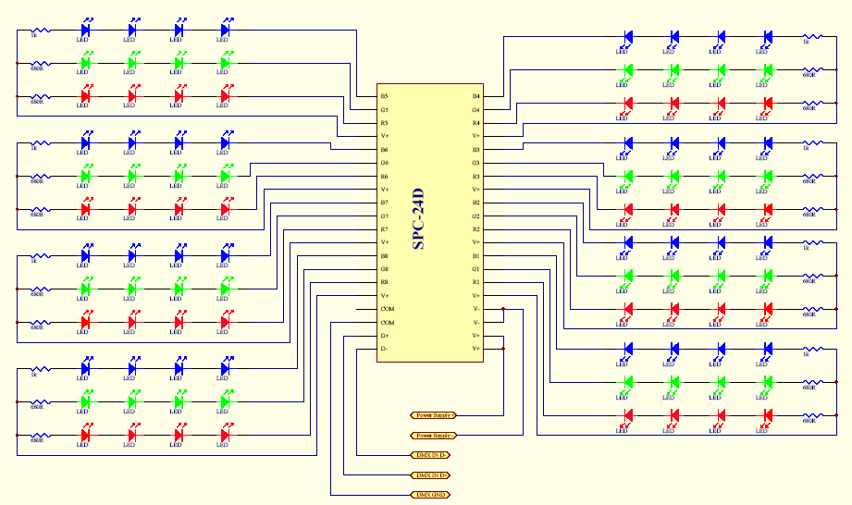
SPD-241
    - Common-anode full-color model sets can directly connect anode lines and line R, G, B to corresponding lines of output interface.
    - Monochromatic model set can connect anode line to line V+ of driven output interface, according to the color of this model set, cathode line is connected to a certain line of pin R, G, B in driven output interface.
    - Monochromatic model sets with several colors are connected to an identical driven output interface, ensuring that all the anode lines connected to line V+ of driven output interface.
  - Interface function description
Interface name | Function description | Characteristic
V+, V- | Power supply input | DC8-28V
D+,D-,COM | DMX512 signal input | 1/4 unit load allows of 128 modules connecting to DMX512 bus. Each dimmer meets or exceeds standard DMX512/1990 and standard ISO/IEC 8482:1993(E).
V+,R1-R8,  G1-G8,B1-B8 | 24 channels driven output ( source-drain open-circuit output) | High level output of each channel: max 28V  Output current: max1A  PWM frequency: 200Hz

2.3 Indication of system operating state
Data indicator light ->off: no signal input
Data indicator light -> glimmering: receiving effective signal.
2.4 Setup of DMX512 start address
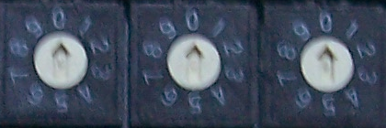
2.4.1 Address is 0, select the start address with DMX Tester’s setting.
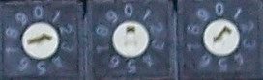
2.4.2 Address is not 0, select the start address with rotary switch’s setting. The start address of this chat is 256, the first rotary switch is hundreds place of decimal system, the second is tens place of decimal system, the third is units place of decimal system.

2.5 DMX512 control signal connection
DMX512 signal cable applies shielded twisted pair cable, DMX512 signal is divided into three categories: positive terminal, negative terminal and GND. Take strict notice of polarity when DMX512 signal cable plug is welded. Connect signal V+, V- and GND of DMX512 controller output with corresponding interface of SPD-241. When the entire circuit is completed, it is supposed to link with a DMX512 signal terminator.
2.6 Power Calculation
Input/output voltage of this product has a wide rang（DC8-24V）, the rated output current is 1A per channel, therefore, the rated output power varies with different input voltage.
For example: the rated power under the circumstances of 12V voltage: 12V*1A*24=288W
the rated power under the circumstances of 24V voltage: 24V*1A*24=576W
2.7 System connection graph

SPD-241
24CH DMX dimmer
LED fixture
SPD-241
24CH DMX dimmer

SPD-241
24CH DMX dimmer

DMX512 controller（SPC-2000）
（SC）
DC12-24V power supply
LED fixture
LED fixture

SHANGHAI SEMPING ELECTRONICS CO. , LTD.
P.C: 200042
Tel: (86)21-5228 8520
Fax: (86)21-5228 8521
Web：www.dmx512net.com
Technical support ：support@dmx512net.com
Add: Room 1706, NO. 868, Changping Road, Jing’an District, Shanghai

