SPC-1000 DMX Hardware player
Manual
REV 1.0
2008.8.15

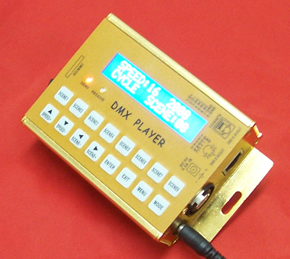

SHANGHAI SEMPING ELECTRONICS CO.,LTD.
Add: Room 1706, NO. 868, Changping Road, Jing’an District, Shanghai
P.C: 200042
Tel: (86)21-5228 8520
Fax: (86)21-5228 8521
Web：www.dmx512net.com
Technical support ：support@dmx512net.com
Chapter 1 brief introduction of SPC-1000
1.1 Summary
SPC-1000 is a DMX player of our company specially designed for LED control system. It adopts 32-bit high-speed ARM processor, making transition of light scene to be more delicate and ensuring excellent reliability. It can display media file, such as Flash cartoons, videos, images, onto lighting art environment, through reading scene files in card MMC/SD.
1.2 Features:
1. Built-in calendar, system clock real-time display.
2. Support manual, cycle, timing and other display modes, adjustable play speed with 16 levels.
3. Fast switchover among several scenes with 8 shortcut keys.
4. Compatible with DMX512 console, scene fading time can be customized.
5. International standard DMX512/1990 signal output, 512 DMX channels (170 full-color RGB pixels) can be controlled.
1.3 Technical Specifications:
Model: SPC-1000
Input Voltage: DC 9V
Output Power: max 1 W
Operating temperature: -20℃- 60℃
Digital signal input/output: DMX512
Digital signal connector: XLR 5PIN*1 RJ45*1
Size: 100(W)*50(H)*125(L) mm
Weight: 500 g
Chapter 2 Application method of SPC-1000
Connect DC 9V power supply to SPC-1000, turn on its power switch, LCD shows as follows:

S E M – P I N G
S P C – 1 0 0 0 V1.0

SPC-1000 enters into self-testing mode, check file M01C001, M02C001…, M20C001 in turn, then it enters into this surface as follows:
SPEED : 16 09 : 30
MANUAL SCENE : 01
SPEED: 16 indicates that current play speed is level 16. Level 1 is the slowest speed, and level 16 is the fastest. You can adjust play speed with SPEED+ and SPEED-
09:30, it is system time, time-sharing displays Year, Month, Day, Week, Clock.
MANUAL represents current mode is manual display mode. Select the current display mode with mode key.
There are 3 kinds of display mode: 1. MANUAL, 2. CYCLE, 3. TIMING.
1. MANUAL: Manual display mode can choose scene number to be displayed by SCENE+, SCENE- and shortcut scene keys.
2. CYCLE: System displays several scenes in SD card circularly. It can choose the current scene number by SCENE+, SCENE- and shortcut scene key.
3. TIMING: System displays scene number in accordance with parameters set by timing play list. The current scene number can be chosen by SCENE+, SCENE- and shortcut scene keys.
For example: Set parameters of play list as follows:
1. S01 ST:08:00 ON
2. S02 ST:08:30 ON
3. S03 ST:08:40 OFF
The first item means display No.1 scene at 8:00, S01 represents No.1 scene, ST represents start time, ON indicates this option is opened.
The second item means display No.2 scene at 8:30.
The third item means display No.3 scene at 8:40, but this option is closed.
The system play process is like this: when system time is 8:00, it begins to play No.1 scene, when it is 8:30, plays No.2 scene till 7:59:59 the next day. It will switch to No.1 scene while system time is 8:00. Because the third item isn’t open, system will not play No.3 scene.
SCENE: 01 the scene number system currently plays.
Initialization: initialize system clock when you find system clock doesn’t move. Press the key SCENE1, then turn on the power switch, if LCD shows as follows, it means system time has initialized.
INITIALIZTION
DATE AND TIME
System initialization time is 00:00 am, Tuesday, January 1, 2008

Chapter 3 Parameter adjustment of SPC-1000
3.1 Parameter adjustment of timing play list
Press key MENU to select TIMING PLAY SET, and LED shows:
TIMING PLAY SET
S 01 ST : 00 : 00 OFF
3.1.1 AT the beginning, LCD flickers at the position of S01.Through key , you can adjust the position where LCD flickers, meanwhile adjust the scene number via key .
3.1.2 After finishing adjustment of each parameter, press key ENTER to save current setup. If LCD shows like so, it means that overlay has occurred when setting start time, please reset it.
TIMING PLAY SET
START TIME ERROR
3.2 Date adjustment
Press key MENU to select DATE ADJUST, LCD shows:
DATE ADJUST
2 0 0 8 / 8 / 1 5 F r i.
3.2.1 AT the beginning, LCD flickers at the position of 2008.Through key , you can adjust the position where LCD flickers, meanwhile adjust its value via key .
3.2.2 After completing date adjustment, press key ENTER to save current setup.
3.3 Time adjustment
Press key MENU to select TIME ADJUST, and LCD shows:
TIME ADJUST
1 0 : 3 0
3.3.1 AT the beginning, LCD flickers at the position of 10.Through key , you can adjust the position where LCD flickers, meanwhile adjust its value via key .
3.3.2 After completing time adjustment, press key ENTER to save current setup.
Chapter 4 Operation on card MMC/SD
4.1.1 Card MMC/SD format
In Windows environment:
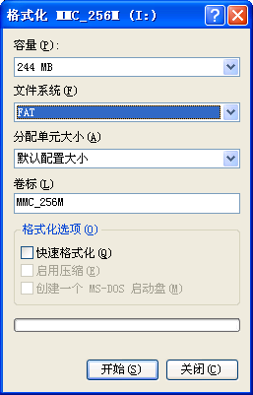
It is necessary to choose FAT file system, for at present SPC-1000 doesn’t support FAT32 file system.
Need to set volume label, such as: SD_256M
Do not pitch on the Quick Format option.
Set as on the chart above, then click the key Start, card MMC/SD formatting will be completed.
4.1.2 Copy and modification of scene file
After formatting, copy the files generated by DMX512 LED Editor to card MMC/SD. (Please refer to DMX512LED Editor_V1.0 Manual of our company to look into how to use LED Editor software).
Notes:
1. Please choose proper mode, M01-M20 is valid.
2. Remain ID to be 1 invariably.
3. While define controller’s line, please choose DMX 1 invariably.
4. Do as the 3 points above, valid scene file available for SPC-1000 will be generated.

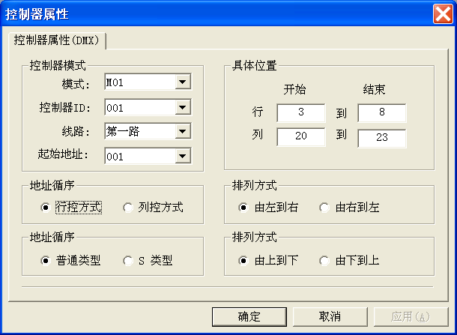
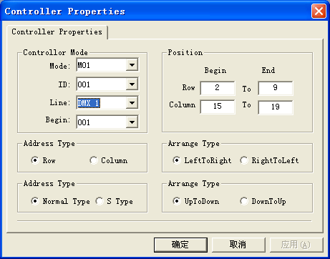

Chapter 5 Troubleshooting and Maintenance
1： Fault ：After connection of 9V DC power, turn on the power switch, LCD displays abnormally.
Solution：Check 9V DC input plug contact, measure it with Multimeter, if fault can not be ruled out, disconnect the power, and contact the company's technical support department.
2： Fault:：LCD display works normally, but SPC-1000 is unable to send or receive DMX signal.
Solution：Check whether joint RJ45/XLR5 connects to SPC-1000 with good contact. If trouble still exists, contact the company's technical support department.
3： Fault: The data which controller transmits are improper.
Solution ：Please confirm that copy of scene file M**C001.SC is correct, that is , firstly set volume label for MMC/SD , secondly format in the form of FAT pattern, at last copy the file. At the time of controller’s line definition, please choose Line: DMX1. If you choose Line: DMX2, controller will have false output.
Notes: A: unplug card MMC/SD while it is live is not allowed.
B: when insert MMC/SD card, a clicking sound indicates it has been plugged. While draw it out, ensure that the card is pressed to the bottom, then loosen it, in the end it will pop automatically.
C: Non-professionals are strictly forbidden disassembling the maintenance.

SHANGHAI SEMPING ELECTRONICS CO.,LTD.
P.C: 200042
Tel: (86)21-5228 8520
Fax: (86)21-5228 8521
Web: //www.dmx512net.com
Technical support：support@dmx512net.com
Add: Room 1706, NO. 868, Changping Road, Jing’an District, Shanghai

