SPC - 2000B
DMX Intelligent Lighting Controller
Manual
REV 1.0
2008.11.27

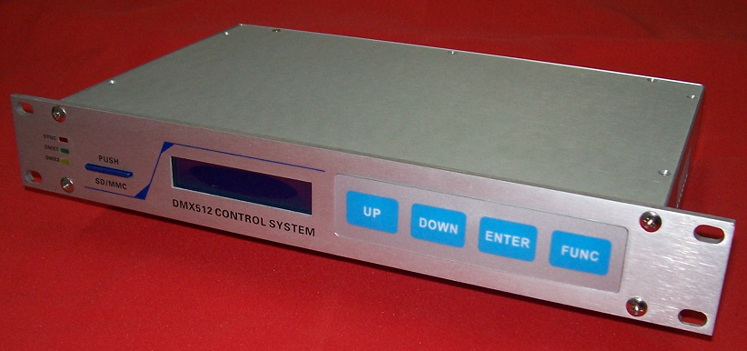

SHANGHAI SEMPING ELECTRONICS CO.,LTD.
Add: Room 1706, NO. 868, Changping Road, Jing’an District, Shanghai
P.C: 200042
Tel: (86)21-5228 8520
Fax: (86)21-5228 8521
Web：www.dmx512net.com
Technical support ：support@dmx512net.com
Chapter 1 brief introduction of SPC-1000
1.1 Summary
Adopts DMX control, SPC-2000B is an Intelligent Lighting Controller of our company specially designs for LED fixtures. With the powerful software DMX512 LED Editor, it can realize kinds of complex effect of art lighting scenes. In the offline mode, it supports synchronous operation of multiple controllers, simplifying the traditional master-slave mode, in addition it expands DMX512 output channels. SPC-2000B is not only a host, but also a salve controller. Through Ethernet, it is able to implement remote control
1.2 Features:
1. Two groups of international standards DMX512/1990 signal outputs with photoelectric isolation (2500V isolation voltage), 1024 DMX channels, 340 full-color RGB lamps with 256 gray scale levels for each of R/G/B can be controlled, really achieve true color.
2. 16 * 2 LCD blue screen display, user-friendly operation interface.
3. Support online and offline modes, 2G SD card or MMC card to access the scene files.
4. Support 254 controllers’ network through the LAN, composing a super-large-scale LED lighting control system, a maximum of 80,000 full-color pixels can be controlled.
1.3 Technical Specifications:
Model: SPC-2000B
Input Voltage: AC100 ~ 240V, 50/60Hz
Rated Power: 5W
Operating temperature: -20 ℃ - 60 ℃
Digital signal input / output: DMX512/1990
Digital Signal connector: XLR 5PIN * 4
Network interfaces: RJ45, 10/100M self-adaptive
Size: 300 (W) * 160 (H) * 43 (L) mm
Weight: 1 kg
1.4 Product schematic
D
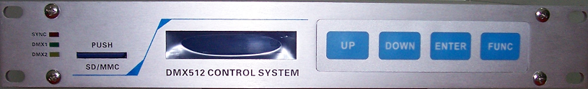
A
B
C
F
E
G

H
I
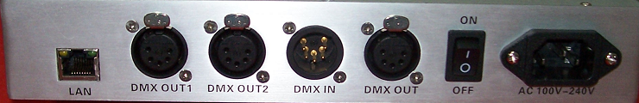
A | Indicator of system state  SYNC： Synchronous signal indicator  DMX1：the first group signal transmission indicator  DMX2：the second group signal transmission indicator
B | SD/MMC socket  （Notes: when insert MMC/SD card, a clicking sound indicates it has been plugged. While draw it out, ensure that it is pressed to the bottom, then loosen it, in the end it will pop automatically. ）
C | 16*2 LCD
D | Function keys
E | RJ45 Crystal-pin plughole
F | Two groups of DMX512 signal output
G | Synchronous signal input/output
H | ON OFF：Power switch
I | AC 100V~240V：AC power supply input socket

1.5 Hardware connection
F
G
E

E: Standard RJ45 network interface, it connects to standard direct network cable, its connection pattern is in terms of standard EIA/TIA568B:
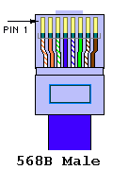

Pin1: connects to orange/white wire Pin5: connects to blue/white wire
Pin2: connects to orange wire Pin6: connects to green wire
Pin3: connects to green/white wire Pin7: connects to brown/white wire
Pin4: connects to blue wire Pine8: connects to brown wire
(Notes: Please be sure wiring is in accordance with the rules above, otherwise the signal attenuation will be very grave.)
F、G: DMX signal and synchronous DMX signal I/O, 5-pin male and female XLR interface is defined as follows:
Pin1 is GND
Pin2 is DATA- of DMX signal
Pin3 is DATA+ of DMX signal
Pin4 is NC
Form what has mentioned above, manufacture of network cable, DMX512 signal line and DMX Synchronous signal line is required to be corresponding respectively, or unexpected trouble will occur to the system. To guarantee stability and reliability, the following requests should be paid more attention:
1: Ensure GND is well connected.
2: It is better to adopt a shielded twisted pair, so that the external Interference to system will be minimized.
3: Valid rang the signal transmits:
A: Transmission distance of DMX synchronous signal line: The length of synchronous signal line between the first controller and the last one must be within 300 meters, otherwise a repeater is required to guarantee that there is no attenuation or attenuation in signal transmission.
B: Transmission distance of DMX signal line: The length form DMX512 signal input port to DMX512 signal bus terminal must be within 300 meters. (It is in relation to the load of DMX fixtures, different fixtures have different valid transmission distance). If beyond 300 meters, it is essential that a signal repeater should be taken to avoid signal attenuation or distortion.
4. System capacity: On the premise of above condition, a synchronous system composed by 64 controllers can be of reliability and stability. If capacity expansion is required, it needs to insert repeaters into controller’s synchronous signal bus, ensuring that signal transmits farther.
Chapter 2 Application Method
Connect AC 100~240 power supply to SPC-2000B, turn on the power switch. LCD displays as follows:

DMX CONTROLLER
INIT … Ver x.x

Then, SPC-2000B enters into Power-on Self-Test.
If SD/MMC card has been inserted, LCD displays:
MMC Card OK!
If SD/MMC card hasn’t been inserted, LCD displays:

MMC Card Fail !
Please Check MMC
If there are a few correct files in SD/MMC card, LCD displays:
OK! M01C001.SC
in MMC Card!
If there are none, LCD displays:
Err! M01C001.SC
isn't in MMC!
Then it returns to main interface, LCD displays:
DMX CONTROLLER
Off M01C001 Menu

Off: Indicates the controller is in the offline mode, it reads the corresponding scene files from SD/MMC card.
On: Indicates the controller is in the online mode, it receives scene signal transmitted by PC software from network.
M01C001: figure 01 behind letter M, indicates the current mode is 01. This control system supports 99 kinds of modes, that is form M01 to M99. Figure 001 behind letter C, indicates the ID number of this controller is 1. This control system supports 999 controllers online, that is form C001 to C999. In multiple offline system consists of many SPC-2000B, a controller whose ID number is 1 is the host, the rest are salves. The host transmits DMX Synchronous signal, and salves receive it. (Notes: only one controller is allowed to set to be host( ID1), or it will leads to system conflict.)
In main interface, press the key FUNC to enter into each menu:
-> A:Set IP Addr
B:Set Net Mask
Press UP/DOWN to set different parameters for A/B/C/D/E, press key ENTER to return to previous menu, and key FUNC to enter the mode of setting different parameters.
A: Set IP Addr Set IP address
B: Set Net Mask Set subnet mask for IP address.
C: set Gateway
D: Set Mode &ID Set mode number and ID for this controller
E: On/Off line Choose online or offline mode
2.1 Setting IP Address
Press key FUNC to enter into IP address setting mode
A:Set IP Addr
->192．168．000．100
Press key UP/down to conduct +/- setting for the parameter to which arrow points.
Press the key ENTER to save IP address, and return to previous menu.
Press the key FUNC to move arrow so as to conduct setup for different parameters.
2.2 Net Mask setting
Enter Net Mask setting mode:
B:Set Net Mask
->255．255．255．000
Press key UP/down to conduct +/- setting for the parameter to which arrow points.
Press the key ENTER to save Net Mask, and return to previous menu.
Press the key FUNC to move arrow so as to conduct setup for different parameters.
2.3 Gateway setting
Enter into Gateway setting mode:
C:Set Gateway
->192．168．000．001
Press key UP/down to conduct +/- setting for the parameter to which arrow points.
Press the key ENTER to save Gateway, and return to previous menu.
Press the key FUNC to move arrow so as to conduct setup for different parameters.
2.4 Mode & ID setting
Enter into Mode & ID setting mode:
D:Set Mode & ID
->Mode=01 ID=001

Press key UP/down to conduct +/- setting for the parameter to which arrow points.
Press the key ENTER to save Mode & ID, then it will get into card MMC/SD searching state, this controller is going to check whether correct file M(Mode)C(ID).SC exists. Several seconds latter, finish searching and return to previous menu. Press the key FUNC to move arrow so as to conduct setup for Mode or ID.
2.5 Online/Offline setting
Enter into Online/offline mode
E:On/Off line
->Offline

Press key UP/down to choose Online or Offline mode.
Press the key ENTER to save IP address, and return to previous menu.
Chapter 3 online system operation
3.1 networking mode
SPC-2000B supports online control. By the DMX512 LED Player of our company, and with the assist of Ethernet, real-time control can be conducted to each Intelligent Lighting Controller which has been linked to Ethernet.( Please refer to DMX512 LED Player Manual to look into how to use DMX512 LED Player.)
In the online mode, the frequency of data transmission is 25Hz (This datum is related to physical architecture of Ethernet, different Ethernet have different measured data). Networking is in terms of the related regulations of standard Ethernet. Network data line is required to be Cat. 5 twisted pair. The length between controller and Network Switch should be within 100 meters, if exceeded, it needs inserting a repeater.
Firstly, set parameters for Intelligent Lighting Controller's network in accordance with the setting method above, and ensure that it is in the online mode. Secondly, run ping 192.168.0.100 –t in PC with the same Ethernet Intelligent Lighting Controller connects to. LCD will display:
Pinging 192.168.0.100 with 32 bytes of data:
Reply from 192.168.0.100: bytes=32 time=2ms TTL=100
Reply from 192.168.0.100: bytes=32 time=2ms TTL=100
Reply from 192.168.0.100: bytes=32 time=2ms TTL=100
It indicates online mode works normally, otherwise please check lines and PC to confirm whether they are normal.

Chapter 4 Operation on card MMC/SD
4.1 Card MMC/SD format
In Windows environment:
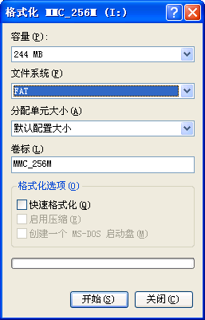
It is necessary to choose FAT file system, for at present SPC-2000B doesn’t support FAT32 file system.
Need to set volume label, such as: SD-256M
Do not pitch on the Quick Format option.
Set as on the chart above, then click the key Start , card MMC/SD formatting will be completed.
  - Copy and modification of scene file
After formatting, copy the files generated by DMX512 LED Editor to card MMC/SD. (Please refer to DMX512LED Editor_V1.0 Manual of our company to look into how to use LED Editor software). If Mode and ID are confirmed, just needs to copy file M(Mode)C(ID).SC into card MMC/SD, then insert card MMC/SD into the controller with corresponding ID. When file size is within card MMC/SD capacity, it is recommended to copy all files into card MMC/SD, for card MMC/SD is with good performance of interchangeability for easy operation.
Modification: in order to ensure the integrality and accuracy of data, please copy the original files from card MMC/SD to PC hard disk before modifying the contest on the card. Then format the card and copy files into it.
Chapter 5 Mechanical size and Installment
Unit of length: mm

Chapter 6 Troubleshooting and Maintenance
1： Fault ：After connection of AC220V power supply, turn on the power switch, but LCD has no response.
Solution：Check AC 220V input plug contact to see that whether AC 220V input is connected. Measure it with Multimeter, if fault still exists, disconnect the power, and contact the company's technical support department.
2： Fault:：LCD display works normally, but SPC-1000 is unable to send or receive DMX512 signal.
Solution：Firstly, see to it that controller is in the DMX transmission state, then check whether joint RJ45/XLR5 connects to SPC-1000 with good contact. If confirmed, contact the company's technical support department.
3： Fault: In offline mode, multi-machine system doesn’t keep synchronous.
Solution: Make sure only one controller’s ID is set to be 1, or it will leads to synchronous signal bus conflict. Refer to Chapter 4 to copy files into card MMC/SD correctly.
Then, take notice of synchronous signal indicator light in the middle of host panel to see whether it flickers within several seconds. If it doesn’t, please contract technical support department of our company. If it flickers, that means the host has sent synchronous signal. Go on to check synchronous signal indicator in the middle of slave panel to see whether it flickers within several seconds. If it does, please contract us. If it doesn’t please examine whether DMX synchronous wiring is in accordance with hardware connection and whether DMX synchronous cable is connected. If the error cannot be ruled out, please contract technical support department of our company.
To improve anti-interference ability of synchronous signal, it is proposed to add two120Ω RS485 terminal resistors to the head-end and terminal of the bus.
4: Fault: in offline mode, the data which controller transmits are improper.
Solution ：Please confirm that copy of scene file M**C***.sc is in accordance with “ Chapter 4 Operation on card MMC/SC”, that is , firstly set volume label for MMC/SD , secondly format in the form of FAT pattern, at last copy the file.
Notes: A: unplug card MMC/SD while it is live is not allowed.
B: when insert card MMC/SD, a clicking sound indicates it has been plugged. While draw it out, ensure that the card is pressed to the bottom, then loosen it, in the end it will pop automatically.
C: Only one controller is allowed to set to be the host, or it will leads to DMX Synchronous signal bus conflict.
D: Non-professionals are strictly forbidden disassembling the maintenance.
E: In the online mode, insert network cable before turn on the power switch.
SHANGHAI SEMPING ELECTRONICS CO.,LTD.
Add: Room 1706, NO. 868, Changping Road, Jing’an District, Shanghai
P.C: 200042
Tel: (86)21-5228 8520
Fax: (86)21-5228 8521
Web：www.dmx512net.com
Technical support ：support@dmx512net.com

