SPC-512 Address Writer & Tester
Manual
REV 1.0
2008.6.26
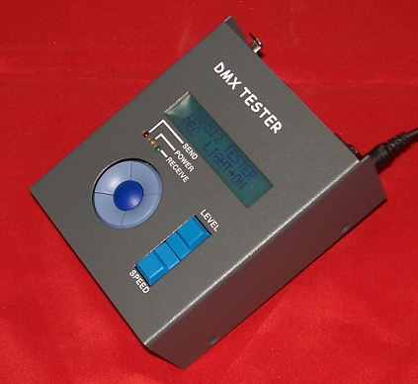

SHANGHAI SEMPING ELECTRONICS CO. , LTD.
P.C: 200042
Tel: (86)21-5228 8520
Fax: (86)21-5228 8521
Web：www.dmx512net.com
Technical support ：support@dmx512net.com
Add: Room 1706, NO. 868, Changping Road, Jing’an District, Shanghai

Chapter 1 brief introduction of SPC-512
1.1 Summary
SPC-512 is an Address Writer & Tester, specifically designed for LED control system. It sets start address of DMX equipment in singles or in batches, replacing traditional setup modes which are depended on dial switch.
Adopting our company’s LED control system composed by DMX Decoder Modules, will avoid troubles from dialing and setting address code for each light. At project site, workers set and dial too much address code, which easily leads to a series of drawbacks, namely dialing fallibility, dialing omission and excessiveness, etc. It also causes trouble to project commissioning. The design scheme for address setting of our company can cope with the troubles above. You just need to install LED fixtures, then, conduct the related operation by DMX Address Writer & Tester to fulfill start address setting for DMX devices of entire system within several seconds. The full course is rapid, reliable, accurate and convenient.
1.2 Features:
1. Compact appearance, light weight, user-friendly operation interface, easy to test at project site.
2. Built-in battery, ultra-low power consumption, more than 100 hours of continuous work.
3. Set start address of DMX equipment in singles or in batches
4. Capable of sending single-channel and multi-channel of DMX signal, support the mode of spot test and effect of fading in/out.
5. Capable of receiving DMX signal, start address, refresh rate and channel value display.
1.3 Technical Specifications:
Model: SPC-512
Input Voltage：DC 9-12 V
Rated power: max 1 W
Digital signal input/output: DMX512
Digital signal connector: XLR 5PIN*2 RJ45*1
Size: 100(W)*50(H)*125(L) mm
Weight: 500g

1.4 Production diagram
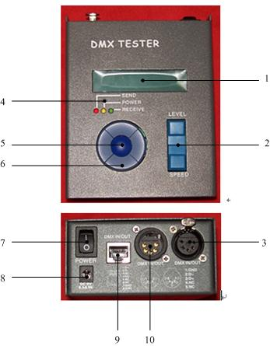
1 | LCD screen | 6 | Circular key( up/down/left/right key)
2 | Up/down key | 7 | Power switch
3 | DMX signal input/output | 8 | Power supply input
4 | Indicator light | 9 | DMX signal input/output
5 | Mode key | 10 | DMX signal input/output

Chapter 2 SPC-512 operation method
2.1 DMX signal transmission mode
2.1.1. DMX single channel test
Press mode key and select DMX OUT, then LCD shows:

DMX OUT 20/S
CH001 --------------- = 000D

CH001 is current control channel, 000D is the value of CH001.
If you want to change the channels currently controlled, up/down keys on circular keyboard adjustment is available.
If you want to change the lightness value of the channels currently controlled, up/down keys adjustment is available.
2.1.2 DMX continuous channels test
Press mode key and select DMX OUT, then LCD shows:
DMX OUT 20/S
CH001 ----- CH003 = 000D
CH001 to CH003 are channels currently controlled, 000D is the value of CH001, CH002, CH003.
If you want to change the start channel currently controlled, up/down keys on circular keyboard adjustment is available.
If you want to change the terminate channel currently controlled, left/right keys on circular keyboard adjustment is available.
If you want to change the lightness value of the channels currently controlled, up/down keys adjustment is available.
2.1.3 Fading in/out test for DMX single channel
Press mode key and select AUTO FADE, then you will find channel value varying all the time, LCD shows:
AUTO FADE 20/S
CH001 -------------- = 127D
CH001 is current-control channel, 127D is the value of CH001.
If you want to change the current control channel, up/down keys on circular keyboard adjustment is available.
If you want to change the speed of fading in/out, up/down keys adjustment is available.
2.1.4 Fading in/out test for DMX continuous channels
Press mode key and select AUTO FADE, then you will find channel value varying all the time, and LCD shows:
AUTO FADE 20/S
CH001 ---- CH003 = 127D
CH001 to CH003 are channels currently controlled, 127D is the value of CH001, 002, 003.
If you want to change the start channel currently controlled, up/down keys on circular keyboard adjustment is available.
If you want to change the terminate channel currently controlled, left/right keys on circular keyboard adjustment is available.
If you want to change the speed of fading in/out, up/down keys adjustment is available.
2.1.5 DMX scene test
Scene Testing function can set value of 512 channels and start code for DMX separately.
Press mode key and select Scene OUT, and LCD shows:
SCENE OUT 20/S D
CH001: 0 1 0 . 0 5 5 . 0 8 6
CH001 is current-control channel, 010 is the value of CH001, 055 is the value of CH002, and 0086 is the value of CH003.
If you want to change the start channel currently controlled, up/down or left/right keys on circular keyboard adjustment is available.
2.1.5.1 Operation method of selecting left/right key:
SCENE OUT 20/S D
C 0 0 9 : 0 1 0 . 0 5 5 . 0 8 6
If current LED flickers at the position of 010, press the left key on circular keyboard, and the start channel currently controlled will turn to 008, and LCD shows:

SCENE OUT 20/S D
C 0 0 8 : 0 0 0 . 0 5 5 . 0 8 6
If current LED flickers at the position of 000, press the right key on circular keyboard, it will arrive at position 055, press the right key again, it will arrive at position 086, press it for the third time, the current start channel will turn to 009, and LCD shows:
SCENE OUT 20/S D
C 0 0 9 : 0 1 0 . 0 5 5 . 0 8 6
2.1.5.2 Operation method of selecting up/down key:
The difference between operation method of up/down key and left/right key is that: left/right key’s step size is 1, while up/down key’s step size is 3. For example, the start channel currently controlled is C009, press the up key on circular keyboard, the start channel will turn to C012, press he down key of circular keyboard, the start channel will return to C009. This operation method is special for LED test, for the channel number of LED fixture is 3CH.
If you need to change current-control channel value, up/down key adjustment is available.
2.1.5.3 If you need to change start code of DMX packet, adjust the start channel currently controlled to C000. LCD shows that start code of current packet is 000, as follows:
SCENE OUT 20/S D
C 0 0 0: 0 0 0 . 0 5 5 . 0 8 6
Adjust LED flicker position to 000 through left/right key on circular keyboard, change its value by means of up/down key. Commonly speaking, the start code of DMX packet is 000.
  - DMX signal receiving mode
Receiving function can accept 512 channels and start code.
Press mode key to select DMXIN, LCD shows:
DMXIN 00H 20/S D
C 0 0 1: 0 1 0 . 0 3 5 . 0 6 6
CH001 is the channel currently viewed, 010 is the value of CH001, 035 is the value of CH002, and 066 is the value of CH003.
00H is the start code of DMXIN, 20/s is the refresh rate of DMXIN.
IF you want to view each channel value of DMXIN, up/down/left/right keys on the circular keyboard adjustment is available. (Step size of up/down key is 3, and the step size of left/right key is 1).
IF input signal of DMXIN is removed, SPC-512 will reserve the last frame. Press up/down key, you can clean the last frame.
2.3 Selection of DMX sending frequency
Adjustment is in the mode of single channel and single fading in/out, 20/s and 40/s are available, selected with the left/right key on the circular keyboard.
For example, in the mode of single channel test, LCD shows:
DMX OUT 20/S
CH001 --------------- = 000D
Press the left or right key on the circular keyboard, LCD shows:
DMX OUT 40/S
CH001 --------------- = 000D

Notes: Selection of the other DMX signal sending frequency is in line with the current setup.
For example, in the single channel test mode, DMX sending frequency is 40/s, therefore, the sending frequency of the rest DMX signal is 40/s as well.

2.4 Setup of Decimal system, Hexadecimal system and Percentage display
On the main interface, LCD shows:
DMX512 TESTER
DEC LIGHT→OFF
System default mode is decimal system display mode. Selection of display mode is available with the left key on circular keyboard.
DEC is Decimal display mode, LCD shows:
DMX OUT 20/S
CH001 --------------- = 128D
HEX is Hexadecimal display mode, LCD shows:
DMX OUT 20/S
CH001 --------------- = 80H
% is percentage display mode, LCD shows:
DMX OUT 20/S
CH001 --------------- = 50%
2.5 LCD backlight setup
On the main interface, LCD shows:
DMX512 TESTER
DEC LIGHT→OFF
LCD backlight is “OFF” by default.
Open or close LCD backlight function with the right key on the circular keyboard.
When LCD backlight is in the state of “ON”, LCD backlight will be opened on pressing the key. The system will close LCD backlight automatically, if there’s no operation within 30 seconds.
2.6 setup of Address writing function
2.6.1 Address writing function is on the closed state by default, if you want to open address writing function, please do some operation as follows:
2.6.1.1 Turn on the power switch, LCD shows:
S E M – P I N G
S P C – 5 1 2 V 1.0
2.6.1.2 Press the left and right key on the circular keyboard simultaneously, LCD shows:
ENABLE DMX
ADDR WRITER FUNC
It means address writing function is open.
IF LCD shows:
DISABLE DMX
ADDR WRITER FUNC
It means address writing function has not opened yet, please repeat the steps above again.

2.6.2 How to write the start address of DMX receiving device?
Press mode key to select PUSH RLUD ENTER( Ensure address function is open, or this menu is invisible), LCD shows:
PUSH RLUD ENTER
DMX ADDR WRITER
Press the left, right, up and down keys on the circular keyboard simultaneously, LCD shows:
DMX ADDR WRITER
A : 0 0 1 . C : 0 3 . D : 0 0 1
A（start address）:001 indicates the start address of the first DMX device.
C（channels）:03 indicates the channel number of DMX receiving devices.
D(devices):001 indicates the total number of DMX devices connected to DMX output joint.(Notes: it only supports devices which can set address in batches, otherwise, this value must be set to 1.)
If you need to modify each parameter, you can adjust the position where LCD flickers through left and right keys on the circular keyboard, then adjust parameters by up and down keys on the circular keyboard.
When adjust start address, the step size of up key and down key on the circular is different. Press the up key, the step size is the number of channels. For example, the current start address is 10, the number of channels is 3, after pressing the up key, the start address turns to be 13 .While the down key is pressed, the step size of start address is 1. This setting method facilitates address writing in batches.
Assume there are 5 DMX receiving devices connected to DMX output joint, each device account for 3 DMX channels, and the start address of the first one is require to be 1, set the parameters as follows:
DMX ADDR WRITER
A : 0 0 1 . C : 0 3 . D : 0 0 5
Press up key or down key to send address writing command, LCD shows:
WRITE ADDR OK
R E A：0 1 6 . R E D : 0 0 5
REA (return start address)= A+C*D
REA returns to the next DMX device’s start address.
RED indicates the number of DMX devices actually return.
After the success of address writing, the start address of the first device is 1, the second one is 4, the third is 7, the fourth is 10, the fifth is 13, and so on.
If LCD shows:
WRITE ADDR ERROR
R E A：0 0 7 . R E D : 0 0 2
It means an error has occurred to address writing, the system only write till the second DMX device’s start address.
If LCD shows:
WRITE ADDR FAIL
CHECK LINE OR DE
It means failure has occurred to address writing, all devices’ start address is unable to be written.

Chapter 3 Replacement of the batteries
Use screwdriver to release 4 screws in the battery-cover, open the battery-cover, then install the batteries, cover it in the end.

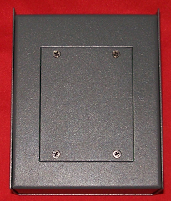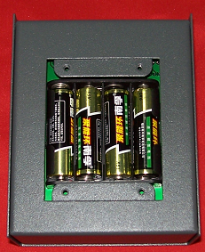
SPC-512 supports 1.5V AAA battery and 1.2V rechargeable battery. When out-connected with 9v power supply, SPC-512 could switch to 9V external power automatically. (Notes: this Address Writer & tester doesn’t support the charging function.)
Please take batteries out, if you don’t use them for a long time.

Chapter 4 Mechanical size
Unit of length: mm
SHANGHAI SEMPING ELECTRONICS CO. , LTD.
P.C: 200042
Tel: (86)21-5228 8520
Fax: (86)21-5228 8521
Web：www.dmx512net.com
Technical support ：support@dmx512net.com
Add: Room 1706, NO. 868, Changping Road, Jing’an District, Shanghai

